TC Cockpit New Enterprise Dashboard Release 1 Deployment Guide

Revision History
Author | Revision Number | Date
TCSASSEMBLER | 1.0 | 1/8/2013

Deployment Instructions 3
1. Organization of Submission 3
2. Application Setup 3
2.1 Ant .Properties File 3
2.2 Configurations 3
2.3 Build Scripts Setup 3
3. Database Setup 4
3.1 Add queries via Query Tool 4
4. Deployment Instructions 4
5. Starting 4
5.1 Start cockpit 5
6. Verification 5
7. Resource Contact List 8

Deployment Instructions

Organization of Submission

The submission follows directory structure provided below:

doc
Contains the Deployment Guide Document of this assembly.

direct
Contains sources and static files for Direct web application. This directory replicates the application development distribution structure and includes only updated and new files.
queries
Contains 1 new query for getting projects pipeline data
test_files
Contains the SQL files to update database schema and insert test data for verification

Application Setup

The application is expected to be deployed to the following environment:

JRE 1.5
JBoss 4.2.3.GA
Informix DS 11.5

Ant .Properties File

Configurations

None

Build Scripts Setup
The ANT build script for Direct application (build.xml) provides the following targets which are to be used:

- switch-and-checkout – checkout or switch to the defined source code branches for all components defined in subprojects.xml
- dist-backend – rebuilt all the components from the source code.
- first_deploy – must be the first task to execute from command line. It will copy all dependencies to your local JBoss folder.
- deploy – should be the main task to execute from command line. It will build and deploy WAR file.
- deploy-static-files – deploys the static files to JBOSS.
- deploy-apache-static – deploys the static files to apache server on VM.

Please refer here for more information:
http://www.topcoder.com/wiki/display/docs/TC+Direct+Setup+Guide

Database Setup

Add queries via Query Tool

Log into the TC Query Tool to add and update queries
(On VM use http://tc.cloud.topcoder.com/query/query)

Add the query enterprise_dashboard_projects
- Choose the database TCS_CATALOG
- Create the query enterprise_dashboard_projectswith the content of queries/ query_enterprise_dashboard_projects.txt
- Add input:
  - tcdirectids
- Create new command enterprise_dashboard_projects
- Add the created new query to the new command

Update the query enterprise_dashboard_total_spend
- Choose the database TCS_CATALOG
- Update the query enterprise_dashboard_total_spendwith the content of queries/ query_ enterprise_dashboard_total_spend.txt
- Save the updated query

Deployment Instructions

This section provides the instructions in Production environment.

- Merge the code from submission into SVN for Direct application including the back end components.
- Build and deploy Direct application using ant deploy (or ant first_deploy) command.
- Copy static files using ant deploy-static-files command (local deployment) or ant deploy-apache-static if use apache as static file server (on VM).

Starting

Start cockpit

- Build and deploy the Direct application
- Start JBoss server instance hosting Direct application

Verification

Set up test data first, run the following SQL scripts in order against the test server database:
- test_files/1) test_data.sql
- test_files/ 2) calendar.sql
- test_files/ 3) milestones.sql

Login into VM as tc to load data to warehouse
- Run ~/web/scripts/dwload] ./loadtcsscript.sh
- Run dos2unix loadweeklystat.sh
- Run ~/web/scripts/dwload] ./loadweeklystat.sh

Upload the test_files/projectBillingLoader to the VM
- cd projectBillingLoader
- run ‘ant run’ to load billing accounts mappings

If you run the projectBillingLoader on local environment, please update projectBillingLoader\conf\config.properties, replace ‘env.topcoder.com’ to ‘localhost’

Use various browsers to open the link http://localhost:8180/direct or https://[vm_ip]/direct/ , login as user / password.

After login go to the page http://<cockpit>/direct/enterpriseDashboard/overview.action

You can see

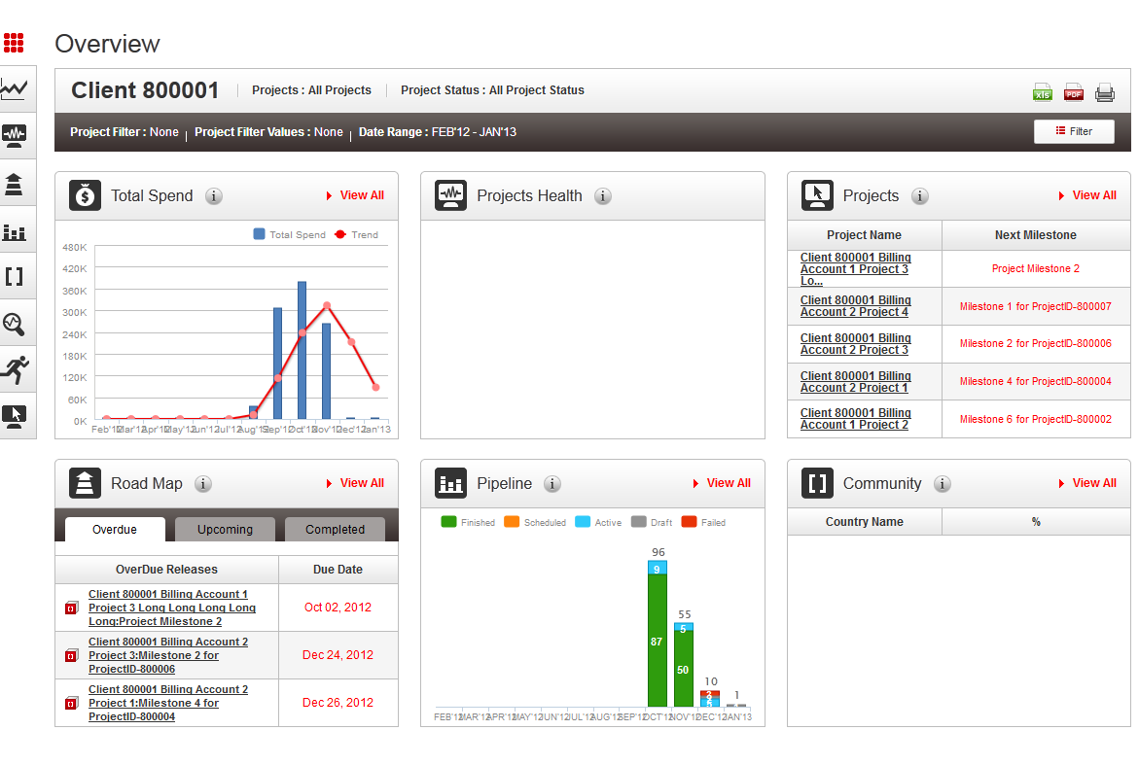

Go the financial page, you can see

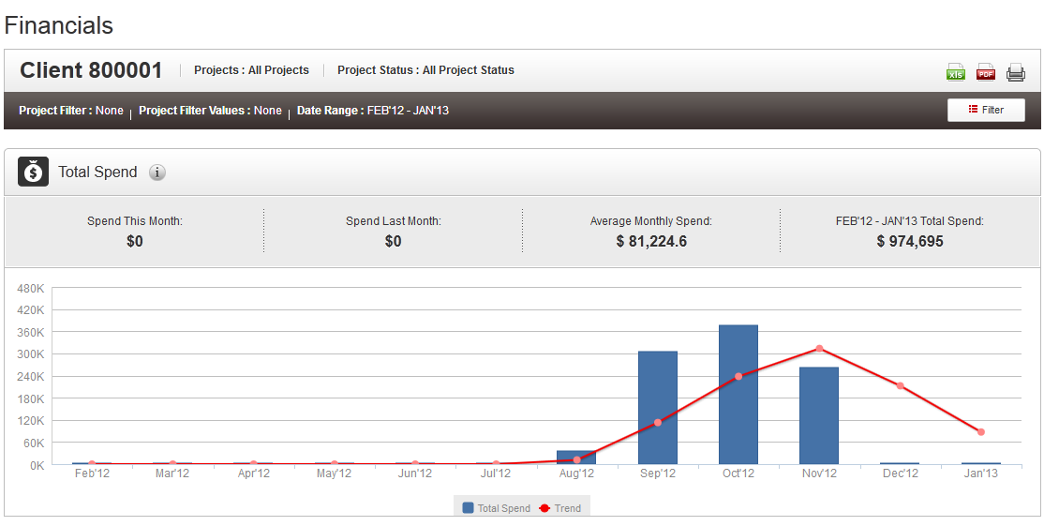

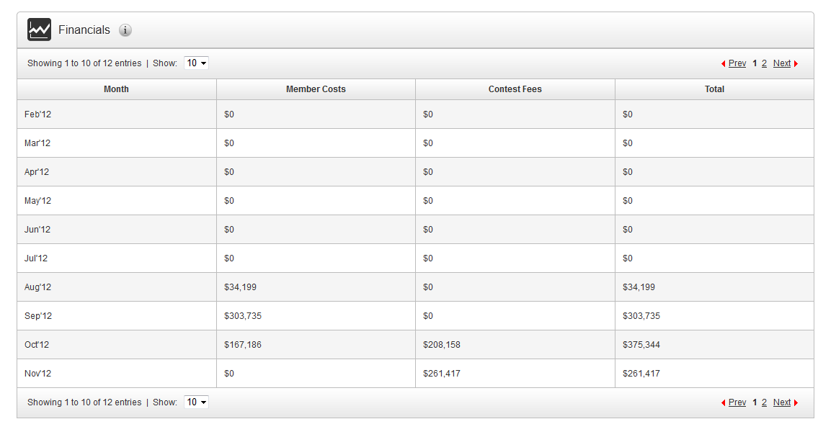

Go to the roadmap page, you can see

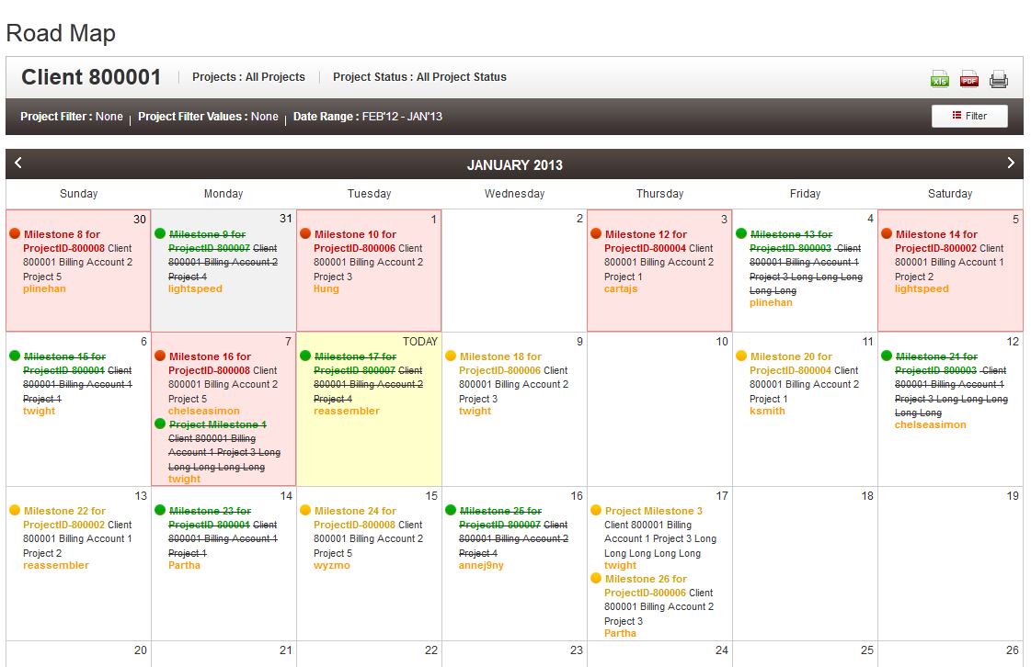

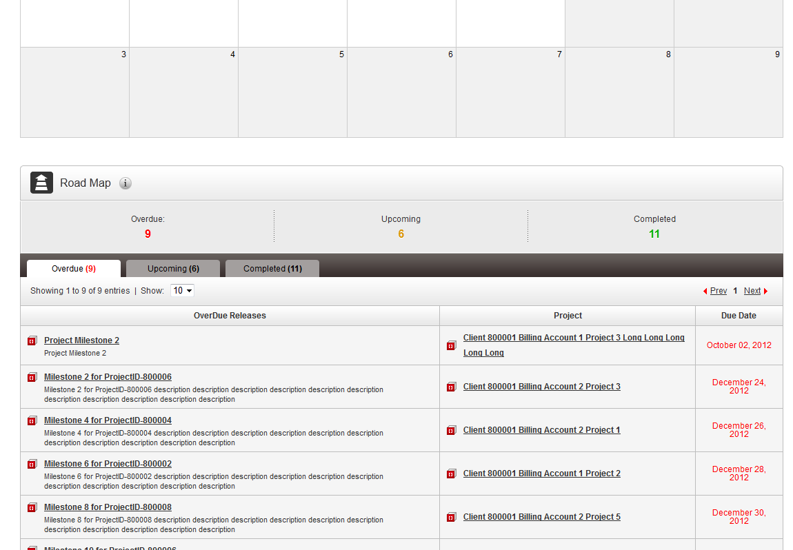

Resource Contact List

Name | Resource Email
TCSASSEMBLER

